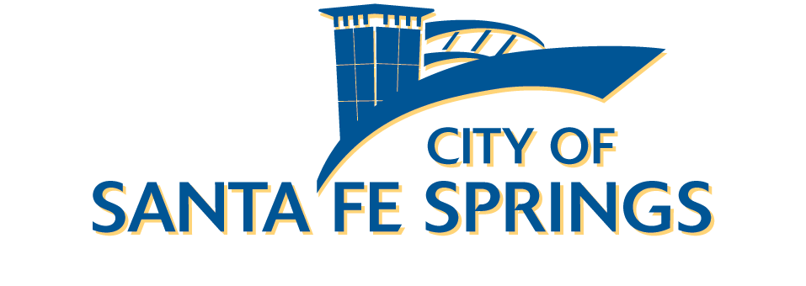

FAMILY & HUMAN SERVICES ADVISORY COMMITTEE

Minutes of Wednesday, October 15, 2025

- CALL TO ORDER
Vice Chairperson Janie Aguirre called the meeting to order at 5:46 p.m.

- ROLL CALL
Members Present: Peggy Radoumis, Elena Lopez, Gabriela (Gabby) Garcia, Gilbert Aguirre, Janie Aguirre, Lisa B. Herrera, Dolores Duran

Members Absent: Elena Lopez, Karla Cardenas

Staff: Ed Ramirez, Community Services Manager, Executive Secretary
Kevin Sanchez-Reyes, Community Services Supervisor
Noah Jimenez, Administrative Assistant

Agency Representative: None.

Guest: None.

- PLEDGE OF ALLEGIANCE – Gabby Garcia

- ORAL COMMUNICATIONS
None.

- APPROVAL OF MINUTES
A motion was made by Janie Aguirre and seconded by Gilbert Aguirre to approve the Minutes for the June 18, 2025, meeting.

- PRESENTATIONS
Tabled to meeting in November.

- EXECUTIVE SECRETARY REPORT
Kevin Sanchez-Reyes went over a recap on past programs:
  - The Backpack Program event resulted in 98 backpacks with school supplies being given out to families and total monetary donations of $5,320 being distributed.
  - Older Adult Excursions to Mercado Gonzalez in Costa Mesa and Santa Monica Pier were well attended and sold out.
  - Family and Human Services (FHS) programs –
    - The Summer Art Camp had travel excursions for the kids to various museums including Hathaway Museum, the Columbia Memorial Space Center in Downey, and Los Alamitos Ranch. The first camp session had 6 children but then rose to the maximum 20 children for the remaining sessions.
    - Summer Concert Series received positive feedback and was well attended by the community:
- June 20: The New Romantics (Taylor Swift tribute) attracted approximately 734 attendees.
- June 27: Just Dave Band (Country) drew about 974 attendees.
- July 3: No concert was held due to the Independence Day Celebration.
- July 11: Kings of Queen (Queen tribute) saw an estimated 1,700 attendees.
- July 18: Soto Band (Latin) brought in around 2,000 attendees.
- July 25: Harry Cats and the Pistachios (Blues/Pop) drew around 1,100 attendees.
- August 1: The series concluded with National Night Out at Los Nietos Park in partnership with the Police Department, featuring a Mariachi performance and roughly 3,300 attendees.
    - The Fun in the Sun adaptive dance took place on August 8th from 9:00 a.m. – 12:00 p.m. at Heritage Park with 175 participants.
    - Pioneer Living Day event took place at Heritage Park on August 15th, with over 700 participants and featured its popular Golden Nugget Hunt.
    - The new Heritage Park Café opened selling various snacks, drinks, and packaged goods. It opened in time with the Summer Concert series.
  - City case managers provided assistance with the following:
    - August – 250 patrons helped, with 168 being residents. $6,790 in monetary assistance provided for Edison and Gas bills.
    - September – 150 patrons helped, with 90 being residents. $2,500 in monetary assistance provided for Edison and Gas bills.
  - The city partnered with the Parking Company of America, based in Commerce, to continue providing transit services to Santa Fe Springs residents who are older adults aged 60 or over or individuals with disabilities.
  - The city will participate in the 2026 Rose Parade, and contracted Phoenix Decorating Company to build the float. Volunteer opportunities will be available for the community to assist with float preparation. Rose Parade tickets go on sale for residents beginning October 20. Tickets are $75 and include transportation and a light breakfast.
  - The Library Café Libro launched and is available for local vendors to operate on select days. The first vendor, JJ’s Sweet Buns, began operations on Wednesday, September 10, and sold out their products during the first two weeks. The library is exploring opportunities to bring in other local operators in the future.
  - The city is now working with a new vendor, 789, Inc., for the City’s rebranding project. The firm has worked with other notable clients such as UCLA Law School and the City of Montebello. The project remains on schedule, with a proposed new City logo expected by the end of November.
  - Thanksgiving Holiday City Facility Closures were announced for all city facilities, including Heritage Park, will be closed for the Thanksgiving holiday on November 27 and 28.
- OLD BUSINESS
None.
- NEW BUSINESS
Mr. Ramirez and Kevin Sanchez-Reyes provided updates on several community programs.
- Monster Mash Bash Adaptive Recreation dance will take place on Friday, October 31st from 9am-12pm at Heritage Park. Will include a costume parade, photobooth, music, and refreshments.
- A volunteer orientation will take place on Wednesday October 22nd at 6:30pm at the Gus Velasco Neighborhood Center for holiday basket volunteers. The deadline for the donation drive is Friday November 7th for the Thankful Neighbor Basket Program.
- Las Posadas will take place on Saturday December 13th at Heritage Park from 6:30 p.m. – 9:30 p.m. the event will have crafts, food, entertainment, and community booths.
- HERITAGE ARTS ADVISORY COMMITTEE REPORT
Kevin updated the committee on actions from the Heritage Arts Advisory Committee.
  - The Rose Float design was finalized and selected.
  - One final submittal to the Public Education Art grant was reviewed and approved that had been submitted on time.
- DIVISION PROGRAM/PROJECT UPDATES
Kevin Sanchez-Reyes provided a brief overview of the following events:
a. Lantern Tours, October 17 @ Heritage Park
b. Veterans Day Ceremony, November 11 @ Town Center Hall Plaza
c. First Friday, Angel Crest String Band, November 7 @ City Library
d. Stream & Sip, November 21 @ Heritage Park

- FUTURE AGENDA ITEMS
Committee members discussed having a potential future presentation on internet technology and scams, as well as a future presentation by police services in regard to a potential neighborhood watch program.
- MEMBER COMMENTS/ANNOUNCEMENTS

- ADJOURNMENT
Vice Chairperson Janie Aguirre adjourned the meeting at 6:30 p.m.

The next meeting is scheduled for Wednesday, November 19th, 2025 at 5:45 p.m. in person at the Gus Velasco Neighborhood Center, Meeting Rm #1.




Kevin Sanchez-Ramirez, Executive Secretary Noah Jimenez, Administrative Assistant

